**Artificial Intelligence**

**What is mean by Artificial Intelligence?**

It refers to the simulation of human **Intelligence** in machines that are programmed to think like humans and memic their actions. The term may also be applied to any machine that exhibits traits associated with a human mind such as learning and problem-solving.

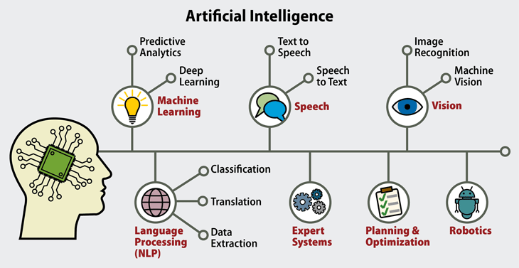

**Why we need Artificial Intelligence (AI)?**

The work **we need** to do is increasing day-to-day. So it’s a good idea to automate the work.

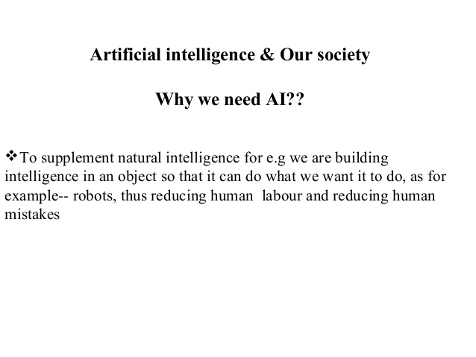

**Top Artificial Intelligence Software:**

**IBM Watson:**

<https://www.ibm.com/watson>

Best AI for the Job

**Engati:**

[**https://www.engati.com/?utm_source=product_listing&utm_medium=product_listing&utm_campaign=product_listing**](https://www.engati.com/?utm_source=product_listing&utm_medium=product_listing&utm_campaign=product_listing)

Best Free Chatbot Platform

**Deep Vision:**

[**https://www.deepvisionai.com/**](https://www.deepvisionai.com/)

Facial Recognition Software

**Cloud Machine Learning Engine:**

[**https://cloud.google.com/ai-platform**](https://cloud.google.com/ai-platform)

Build Superior Models and deploy them

**Salesforce Einstein:**

[**https://www.salesforce.com/products/einstein/overview/**](https://www.salesforce.com/products/einstein/overview/)

Focus on what matters—the customer

**Azure Machine Learning Studio:**

<https://azure.microsoft.com/en-us/services/machine-learning/>

Create Smarter, more insightful solutions

**TensorFlow:**

[**https://www.tensorflow.org/**](https://www.tensorflow.org/)

An open source software library for high-performance numerical computation.

**Applications of AI:**

* Speech Recognition
* Understanding Natural Language
* Image Recognition

**Real time Products in AI:**

**Google Translate:** It can instantly translate more than 100 different human languages.

**Tesla: Self Driving Cars** are being perfected with the help of neural networks

Siri

Alexa

Cortana

**Open AI:** AI bots just beat humans at the video game DOTA 2. That’s a big deal, because their victory required teamwork and collaboration – a huge milestone in advancing Artificial Intelligence. (-- Bill Gates)

**MuseNet:** A Deep Neural Network that can Generate 4-minute musical compositions with 10 different instruments.

**Wordsmith:** It is Natural Language Processing Platform. It is a AI-powered tool that produces written analytics by transforming the given data.